Monthly P&L

## Instructions

Instructions for “Monthly P&L App”

**Please read and follow all the instructions for a proper use of application!**

## Pre-requisites:

1. The monthly trial balances should be stored in the same folder, and each file can/should be renamed with numbers according with the month(ex: 1, 2, 3 for Jan, Feb, March).

If the monthly trial balances are the same, ***modify ONLY for the first month the header*** like the one down below:

|  |  |  |  |  |  |
| --- | --- | --- | --- | --- | --- |
| Cont | Denumire cont | Debitor inceput an | Creditor inceput an | Debitor luna curenta | Creditor luna curenta |

|  |  |  |  |  |  |
| --- | --- | --- | --- | --- | --- |
| Debitor cumulat | Creditor cumulat | Total debitor | Total creditor | Sold curent debitor | Sold curent creditor |

If the excels have not the same structure, modify for each month.

Good to know: even if you don’t have the information for all header column, it is mandatory that you should write in the header all the information presented at point 1.

1. TB template – should be made on the template presented down below:



In the TB Template, map the information from the Trial Balance provided by the client, onto the Template shown here accordingly. (Account, Description, Opening Balance, Movement Debit & Credit and Closing Balance)

|  |  |  |  |  |  |
| --- | --- | --- | --- | --- | --- |
| Account | Description | OB | DM | CM | CB |
| 401 | Vendors | 2.341 | 34.325 | 5.353 | 31.313 |

## Instructions:

1. While connected to VPN, access the server at <http://192.168.1.222:5000/> and select de Ageing webapp from portal:

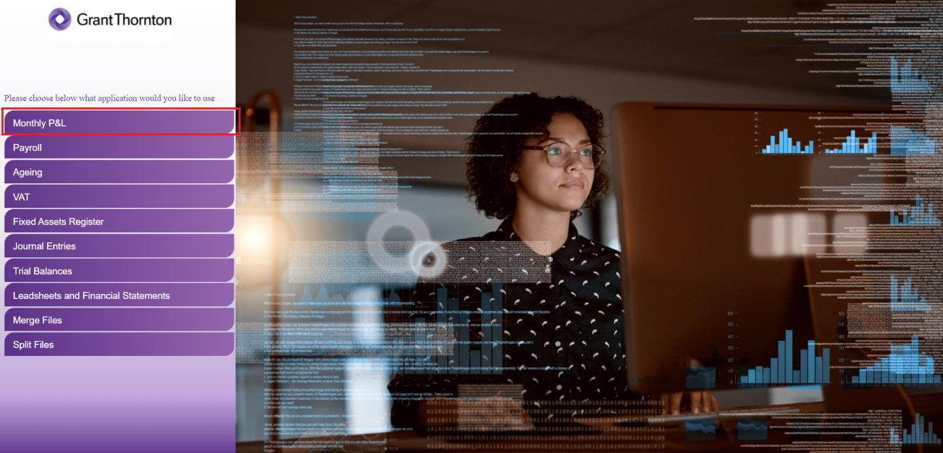

1. In the next page shown below, please enter de details as it follows:

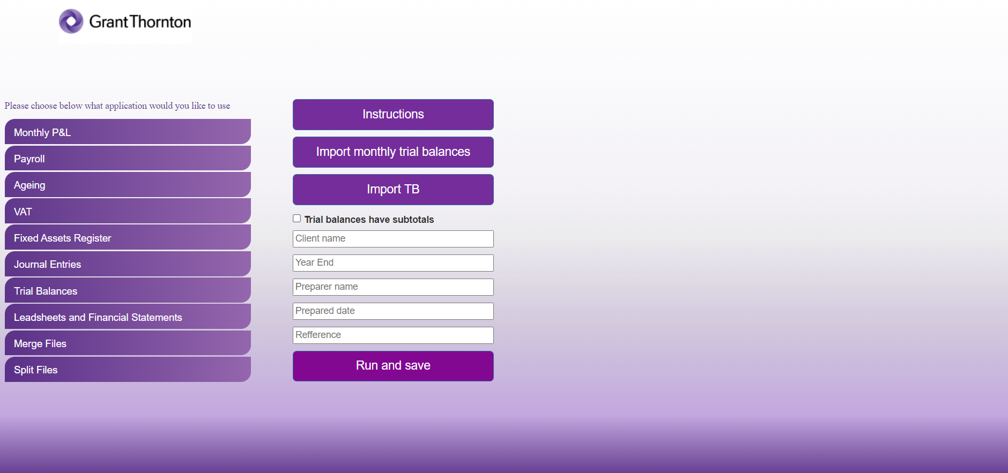

1. Enter the client’s name and the period end (MM/DD/YYYY) of the audit.
2. Click “Import monthly trial balances” button and select the all monthly balances you have saved.
3. Click “Import TB” and import the Trial Balance template.
4. In the following areas, insert your name, date of preparation of the test and desired reference number.
5. Tick the checkbox if the trial balance has subtotals or not.
6. Click “Run and save”. Once clicking that, the robot will ask the desired saving location, will process your request and exit the application, then announce you if the process succeeded.
7. Finally, you should obtain an Excel document named “Monthly P&L and the client name”.

Please keep in mind that a connection to VPN is required in order to use the web applications.

For any issues, questions and/ or suggestions, please contact:

Cristian Iordache, [cristian.iordache@ro.gt.com](mailto:cristian.iordache@ro.gt.com)

Bogdan Constantinescu, [bogdan.constantinescu@ro.gt.com](mailto:bogdan.constantinescu@ro.gt.com)